Citizens For A Better Norwood
Invites you to:

Provided by C. Towne Productions
Where: Norwood VFW- Post 2452 193 Dean Street
When: Friday, July 24, 2026 Time: 6:00pm – 9:00pm
Cost: Individual tickets $25.00 ea. / Table of eight $200.00
**We recommend purchasing tickets in advance, as limited tickets may be available at the door. ** Cash Bar / Bring your own table snacks/ Prizes / 50/50 Raffle/ Raffles.
For ticket information or to register for a table, please contact Ed Lynch at 781-686-7077. For your convenience you can also purchase tickets via Venmo. Please notate your name and how many tickets you are purchasing. Thank you for your support
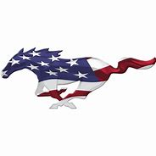

@citizensforabetternorwood
